PCMCIA slot

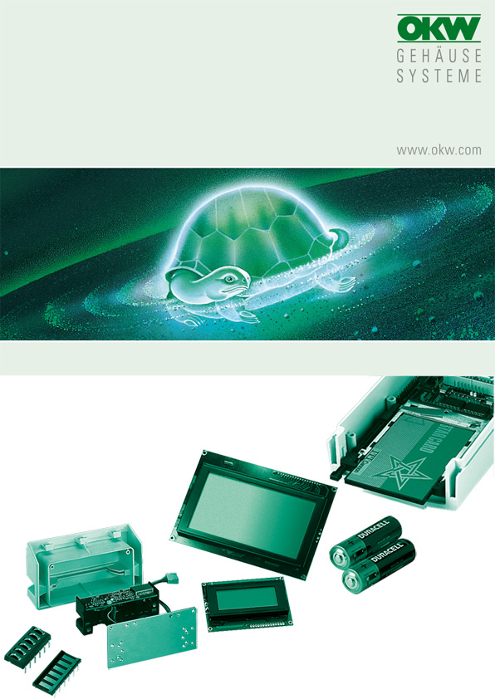

FOR DATEC-CONTROL M/L

The PCMCIA slots are generally screwed or soldered directly onto the PCB.

Manufacturer |  | Source of supply |  | Type/ designation
J.S.T. Japan |  | pb elektro vertriebs-gmbh  Robert-Bosch-Str. 16, 64823 Groß-Umstadt  Phone: +49 (0) 60 78 / 78 09-0  Fax: +49 (0) 60 78 / 7 44 47  info@pb-elektro.de  www.pb-elektro.de |  | Almost all versions of this manufacturer (approx. 200) fit. Please ask the manufacturer/your dealer for the latest catalogue material.
EVG Martens GmbH & Co. KG
Trompeterallee 244-246
41189 Mönchengladbach
Phone:+49 (0) 2166-55080
Fax: +49 (0) 2166-550890
info@evg.de
www.evg.de

No responsibility is taken for the correctness of this information.

Odenwälder Kunststoffwerke
Gehäusesysteme GmbH
Friedrich-List-Str. 3
74722 Buchen/Germany
www.okw.com

