Authorisation switch

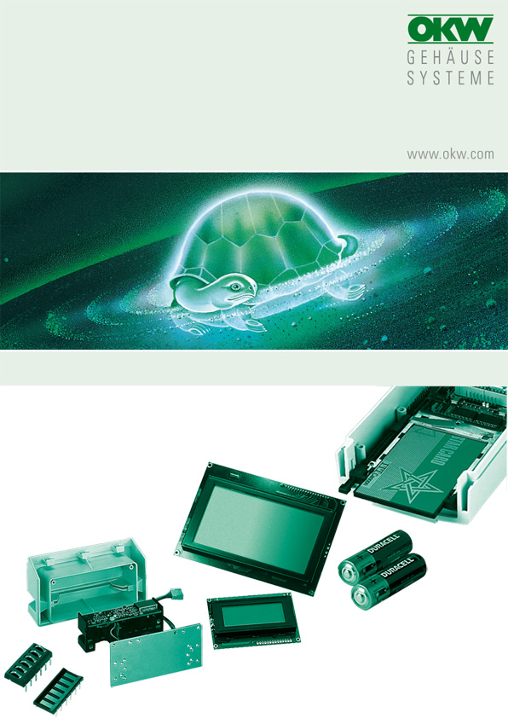

HAND- TERMINAL

The switch "only" has IP 40, and accordingly the protection class of the case is reduced to IP 40, even if seals are used.

Assembly only possible through reworking. The case is milled over from the inside, from the outside two countersunk holes must be drilled and a cutout must be milled.

Manufacturer |  | Source of supply |  | Type/ designation
Idec |  | Idec Elektrotechnik Gmbh  Wendenstraße 331  D-20537 Hamburg  Phone +49 (0) 40 /25 30 54 - 0  Fax +49 (0) 40 / 25 30 54 53 24  service@idec.de  www.idec.de |  | HE 1B-M1

No responsibility is taken for the correctness of this information.

Odenwälder Kunststoffwerke
Gehäusesysteme GmbH
Friedrich-List-Str. 3
74722 Buchen/Germany
www.okw.com

