Batteries

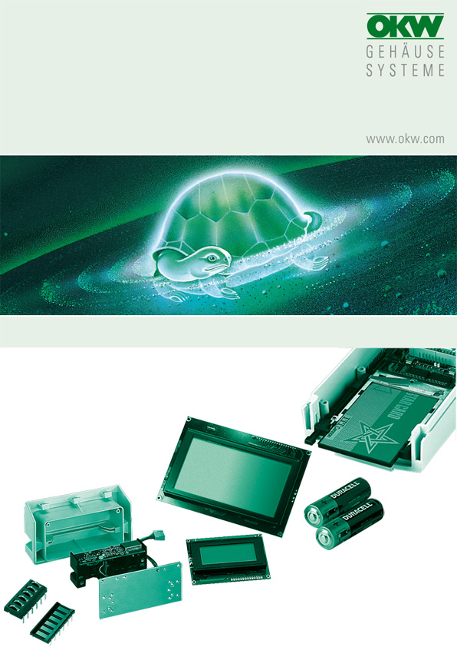

FOR SMART-CASE L, XL (A 90 67 107 / 109 / 209; A 90 68 107 / 109 / 209)

Available in photo shops and consumer markets worldwide. Typical primary batteries / rechargeable batteries for electronic devices of all kinds. Large quantities available direct from well-known battery manufacturers.

2 pieces 1.5 V mignon cells AA (as rechargeable batteries 1.2 V each), Ø 14.5 mm, length 50.5 mm. Battery compartment already integrated in the top part of the case. Contact established by means of set of battery clips A 91 90 002 (accessories with 2 individual contacts and one contact bridge).

Or 1x 9 V flat battery PP3 (as a rechargeable battery 6 V), dimensions approx. 26.5 x 17.5 x 48.5 mm. This can be picked up with the plug-in contact A 91 60 003 (accessories).
Alternatively, contact can be established with the parts 2 x AS052948 "spiral spring on base plate", whereby it is better to insert these transversely. Part 1 x AS050867 "contact bridge" is suitable for pushing in the batteries in a longitudinal direction. As a lateral guide, Tesa Moll strips with a thickness of 2.5 mm should be glued into the compartment.
The 4 higher pegs in the battery compartment lid must be nipped off. The remaining 2 pegs then support the flat battery.

Foam rubber cut to size (Tesa Moll or the like) can be stuck into the lid to prevent the batteries from rattling.

No responsibility is taken for the correctness of this information.

Odenwälder Kunststoffwerke
Gehäusesysteme GmbH
Friedrich-List-Str. 3
74722 Buchen/Germany
www.okw.com

